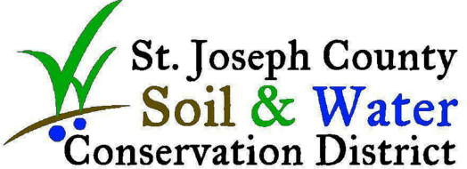

Thank you for checking out a St. Joseph County SWCD environmental education resource! While most resources/supplies can be adapted to different age groups, some are more appropriate for specific age groups or audiences; please be sure to read each resource’s specific description beforehand.

Resources/supplies guidelines:
- Please handle resources/supplies with care. We want them to last a long time so that many others can use them.
- Accidents happen! If something should get damaged, please let us know when you return it so that we can fix the issue. Please also let us know if you find any other issues with the resources/supplies. **
- Please keep things clean. For items that cannot be easily cleaned (such as furs), please avoid having food, drinks, or other liquids nearby while using them.
- Some resources/supplies come with a checklist. Check the checklist before and after use. When you return the resources/supplies, let us know if anything is missing. If there are any consumable items that are running low, please let us know.
- Make the resources/supplies your own! You can use our lesson plans or make your own to fit your curriculum. Use them as you see fit!

**Note: Please exercise special care if you are borrowing the augmented reality 3-D sandbox as this equipment is more high-tech and delicate. In the event that the sandbox equipment gets damaged or goes missing due to negligence while in your care, you and your party will be responsible in the repair and/or replace of that equipment.

Thank you for using our resources to help share conservation education! Please let us know if you have any questions or suggestions of how we can improve our resources/supplies.

Best,
The St. Joseph County Soil and Water Conservation District

